Lab Practical #12:
Following the user flow design the Low-Fidelity wireframes for the Food Delivery app.

Practical Assignment #12:
Design the Lo-Fi wireframes for one critical user flow:
'Ordering a Meal' (from 'Restaurant List' -> 'Menu' -> 'Add to Cart' -> 'Checkout').

Description:
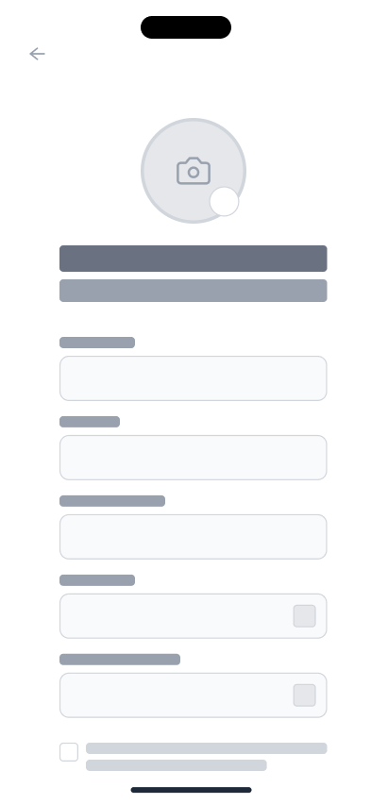
Registration Screen

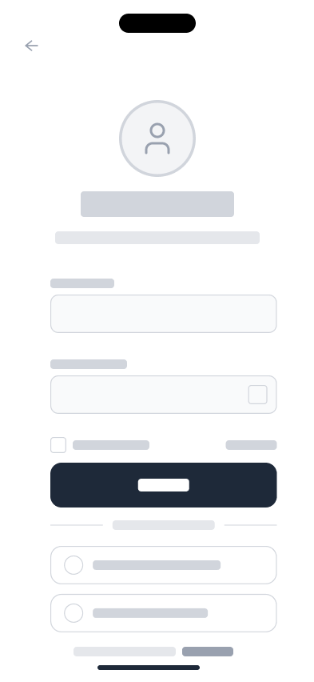
Login Screen

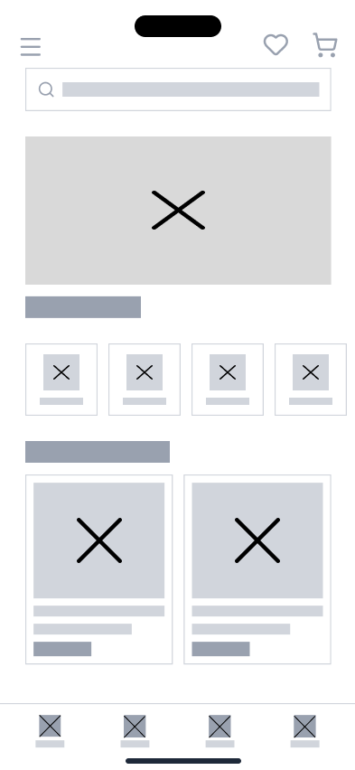
Home Screen

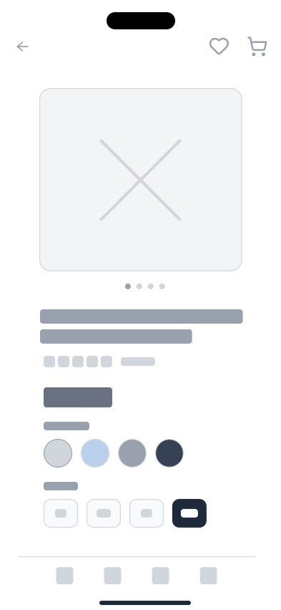
Product Screen

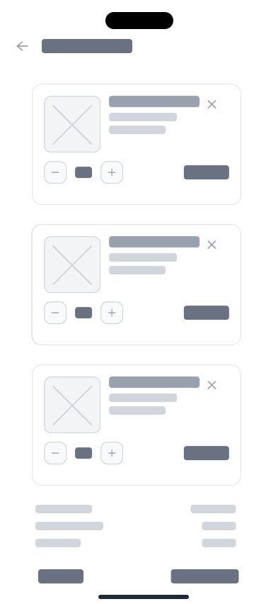
Cart Screen

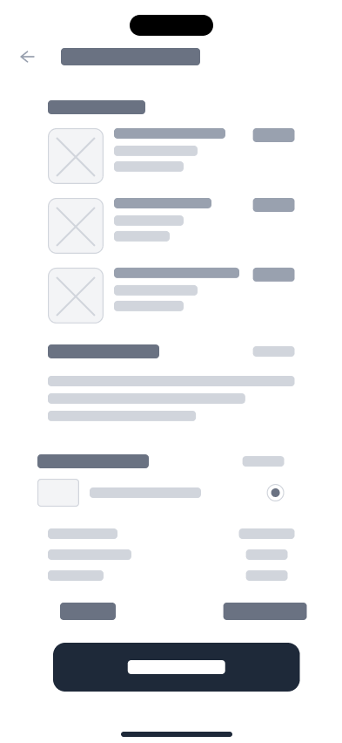
Order Screen

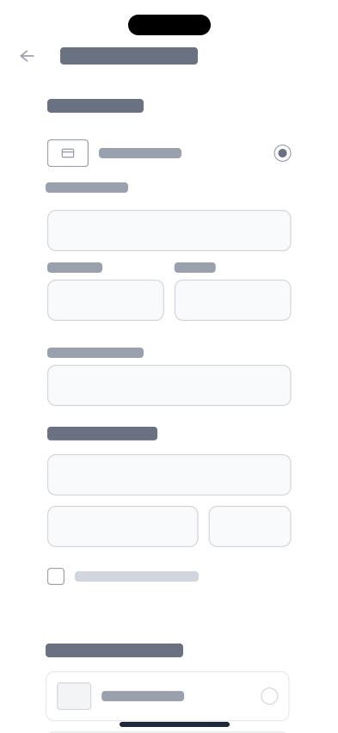

Payment Screen

